POLITÉCNICO INTERNACIONAL

Review Test

1. ***Fill the conversation questions and answer them according to the picture information.***

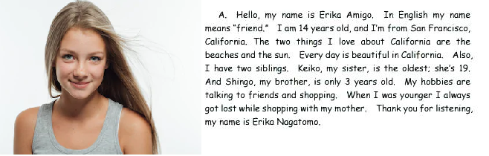

***1. What __is_ your name?***

***__________________________________________***

***2. - How old _are you?***

***__________________________________________***

***3. Are __you_ male or female?***

***__________________________________________***

***4. Which country _are_ you from?***

***__________________________________________***

***5. Which city/area __are_ you living in?***

***__________________________________________***

1. Put the verb in brackets in the correct form (present simple or present continuous)

Next week, my friends and I will go camping in the woods. I ____organize__ _____ (organize) the food, because I ____like_____ _ (like) cooking. Dave ______has_________ (have) a big car with a trailer, so he ______plans________ (plan) the transportation. Sam _____goes______ (go) camping every year, so he ____has_ (have) a great tent and lots of other equipment. Sam _____packs_____ (pack) right now. My wife __thinks__ (think) we're crazy. She ___doesn’t like________ (not like) to stay in the woods. She (like) _____likes_____ holidays in comfortable hotels, so she _____takes___ (take) a trip to Paris instead.

1. **Write down the comparative or superlative of the adjectives in the brackets.**
2. The Nile is (long) ____longest_______ river in the world.
3. My desk is (clean) ____cleaner______ David's.
4. A continent is (big) ____bigger_____ a country.
5. **Write the correct object pronoun. (me, you, her, him, it, us, them)**
6. I’m busy right now. Could you please call **him** after an hour?
7. He gave me the box, but I lost _____it_______.
8. We gave him the money, and he gave _____us____ the candy.
9. Who is she? Do you know ______her____ name?
10. **write down your daily routine.**

1._I usually get up at 8:00 am, I take a shower at 8:30 am, I get dressed at 8:40 am, I have breakfast at 9:00 am, and I brush my teeth at 9:30 am.

2._I organize my room and listen to music, at noon I have lunch at 12:30 pm with my mom and my sister.

3._Later, I connect virtually to the systems classes, at 2:00 pm, I do my homework in the afternoon.

4._I have dinner at 7:30 pm, at 8:00 pm I watch TV, and I watch Facebook when there commercials on television.

5._Finally at 9:50 I brush my teeth, I go to bed at 10:15 pm and I make a prayer.